- Not able to schedule for any times other than start of the hour in dashboard.
- AI chatbot modes: Globe and Web symbols significance is not obvious
- When clicked on specific saved sample, back routing is not linked to specific experiment instead it’s going to whole project.
- LAB NOTES:
- In pic below from lab notebook, instead of scrolling option for features, better give stretchable ribbon option like MS word so that all features/options are visible, considering reducing space between name and features to fit more features in single view (highlighted in red box).
- In lab notes, how do I move table or image position?
- In lab notes, is it possible to provide options when you right click? Just like in word
- Why ctrl+B is closing and opening side car along with regular bolding of text in labnotes. (Bolding the text is fine but side car response is unexpected)
- Insert image option -> take photo is not working
- Image URL option also doesn’t seem to work
- Chemical formula option doesn’t seem to work
- Inline equation could not create following equation: EE% = ((Total-Free)/(Total))*100
- Not able to find citation for following text: “Glioblastoma (GBM) is an aggressive, grade IV brain tumor that develops from astrocytes located within the cerebrum, resulting in poor prognosis and survival rates following an accepted treatment regimen of surgery, radiation, and temozolomide.“
- When clicked on reports within a project, dropdown asking for project selection again, can remove it.
- No use in providing staging option for closed access papers and rendering of journal and authors seems to be issue for some results (refer pic below)
- Catalyst AI citations was not able to redirect me to source from which it retrieved info. For ex: it was able to show me labnote I asked for, but when I clicked it couldn’t take me to labnote and instead error (refer pic below) 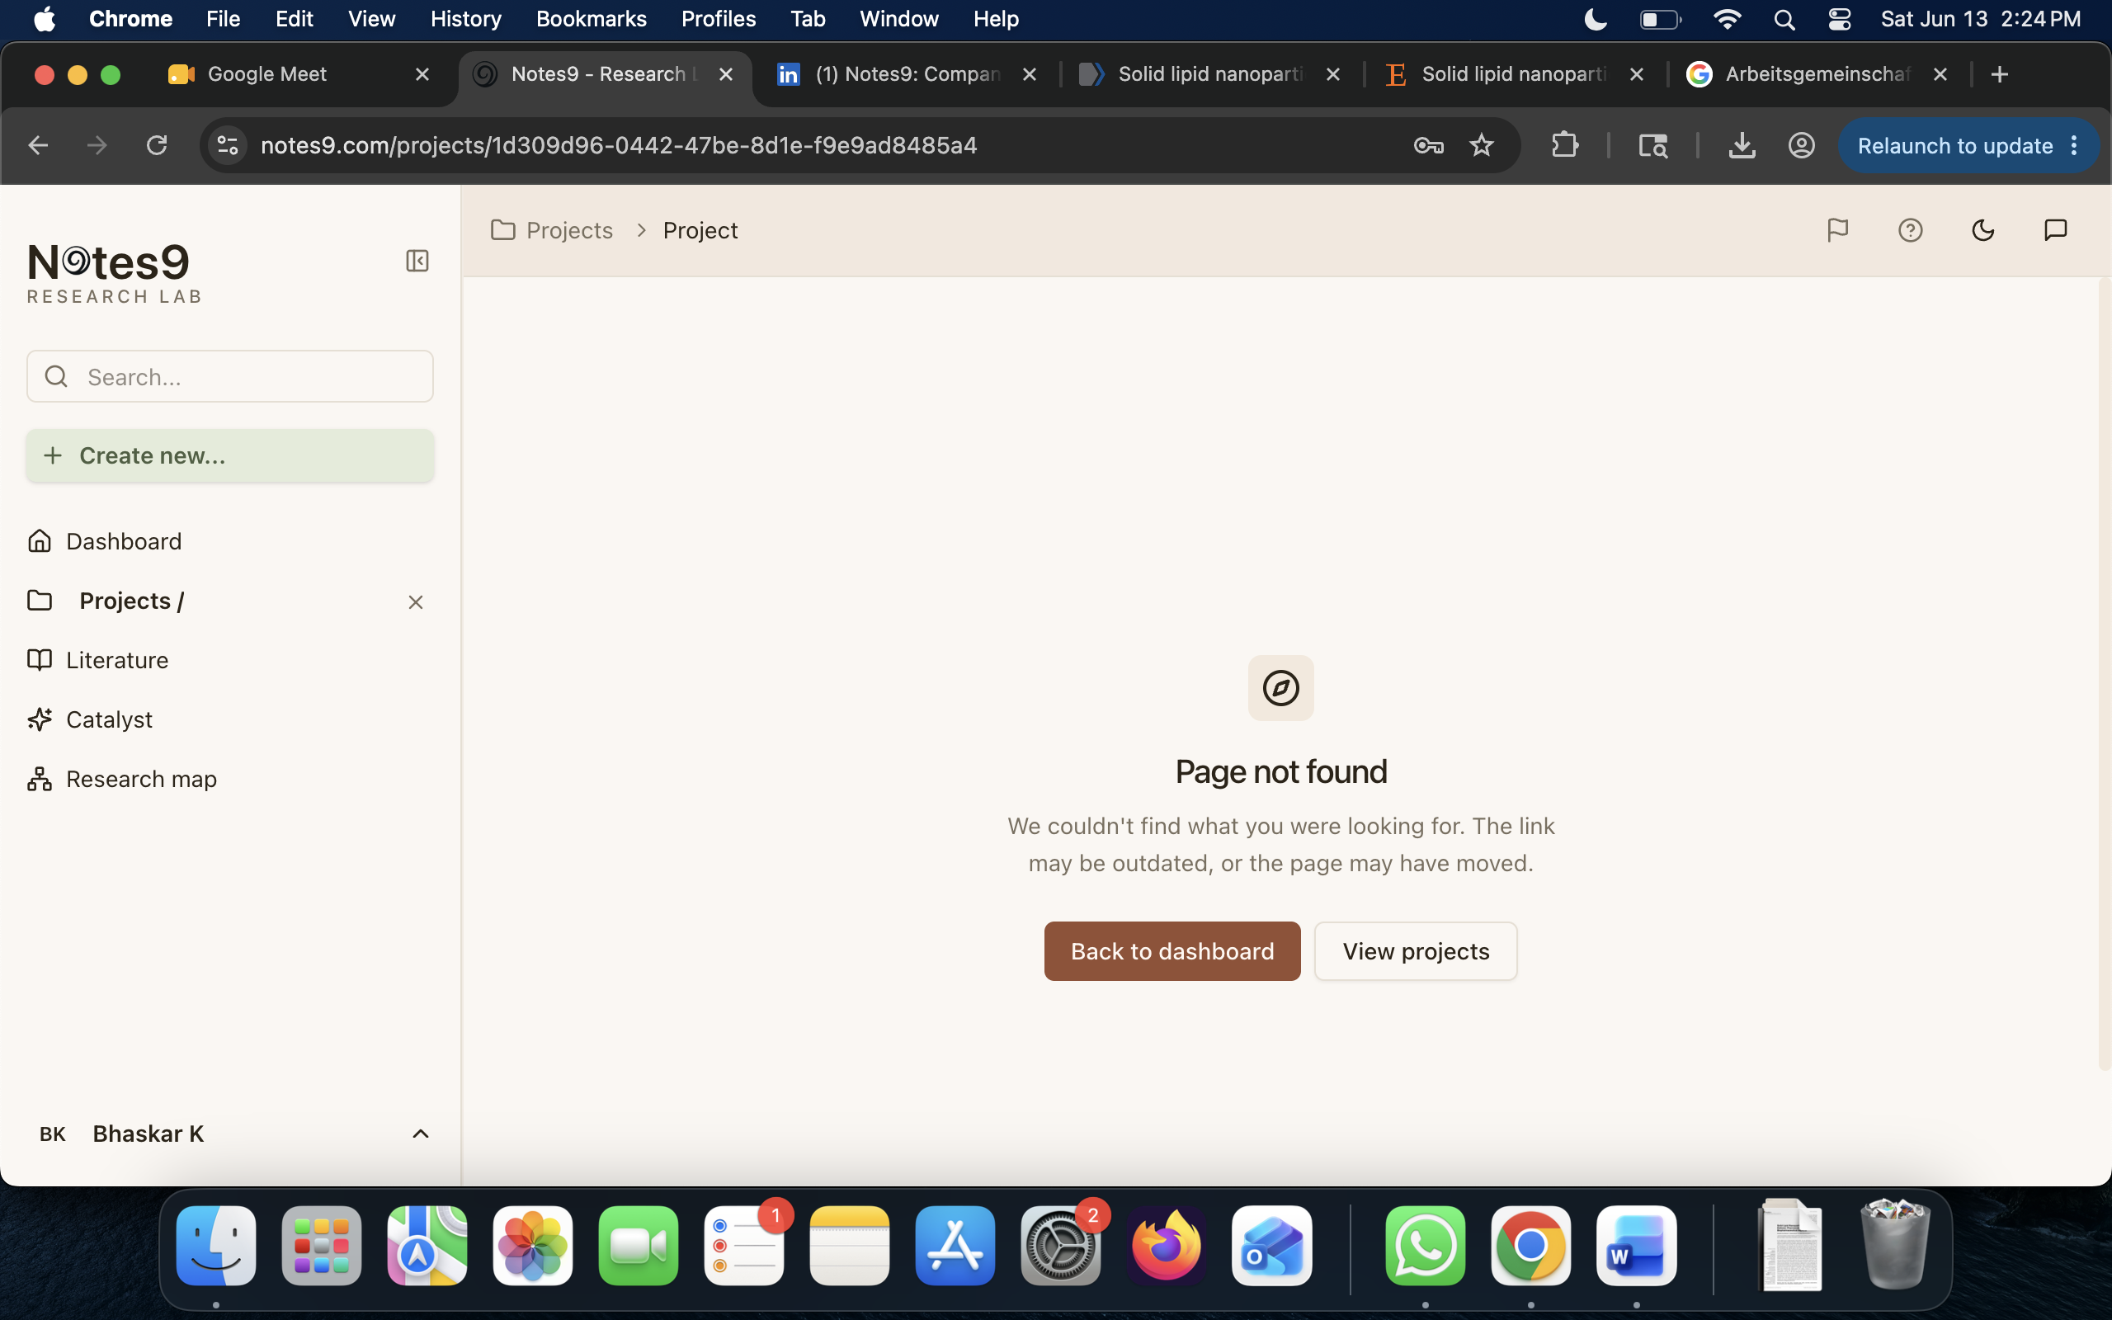

- In catalyst AI, why not also provide folder option, so that user can create folders for specific set of tasks and context is reserved for user to scroll old convos in that folder just like chatGPT. It acts like a tag for specific type of AI conversations.
- Option to share AI convo just like regular AI tools.
- In research map, consider including logos for different blocks (i.e., literature logo, exp logo, project logo), color coding is good but logos might make it even more easier to differentiate boxes.

